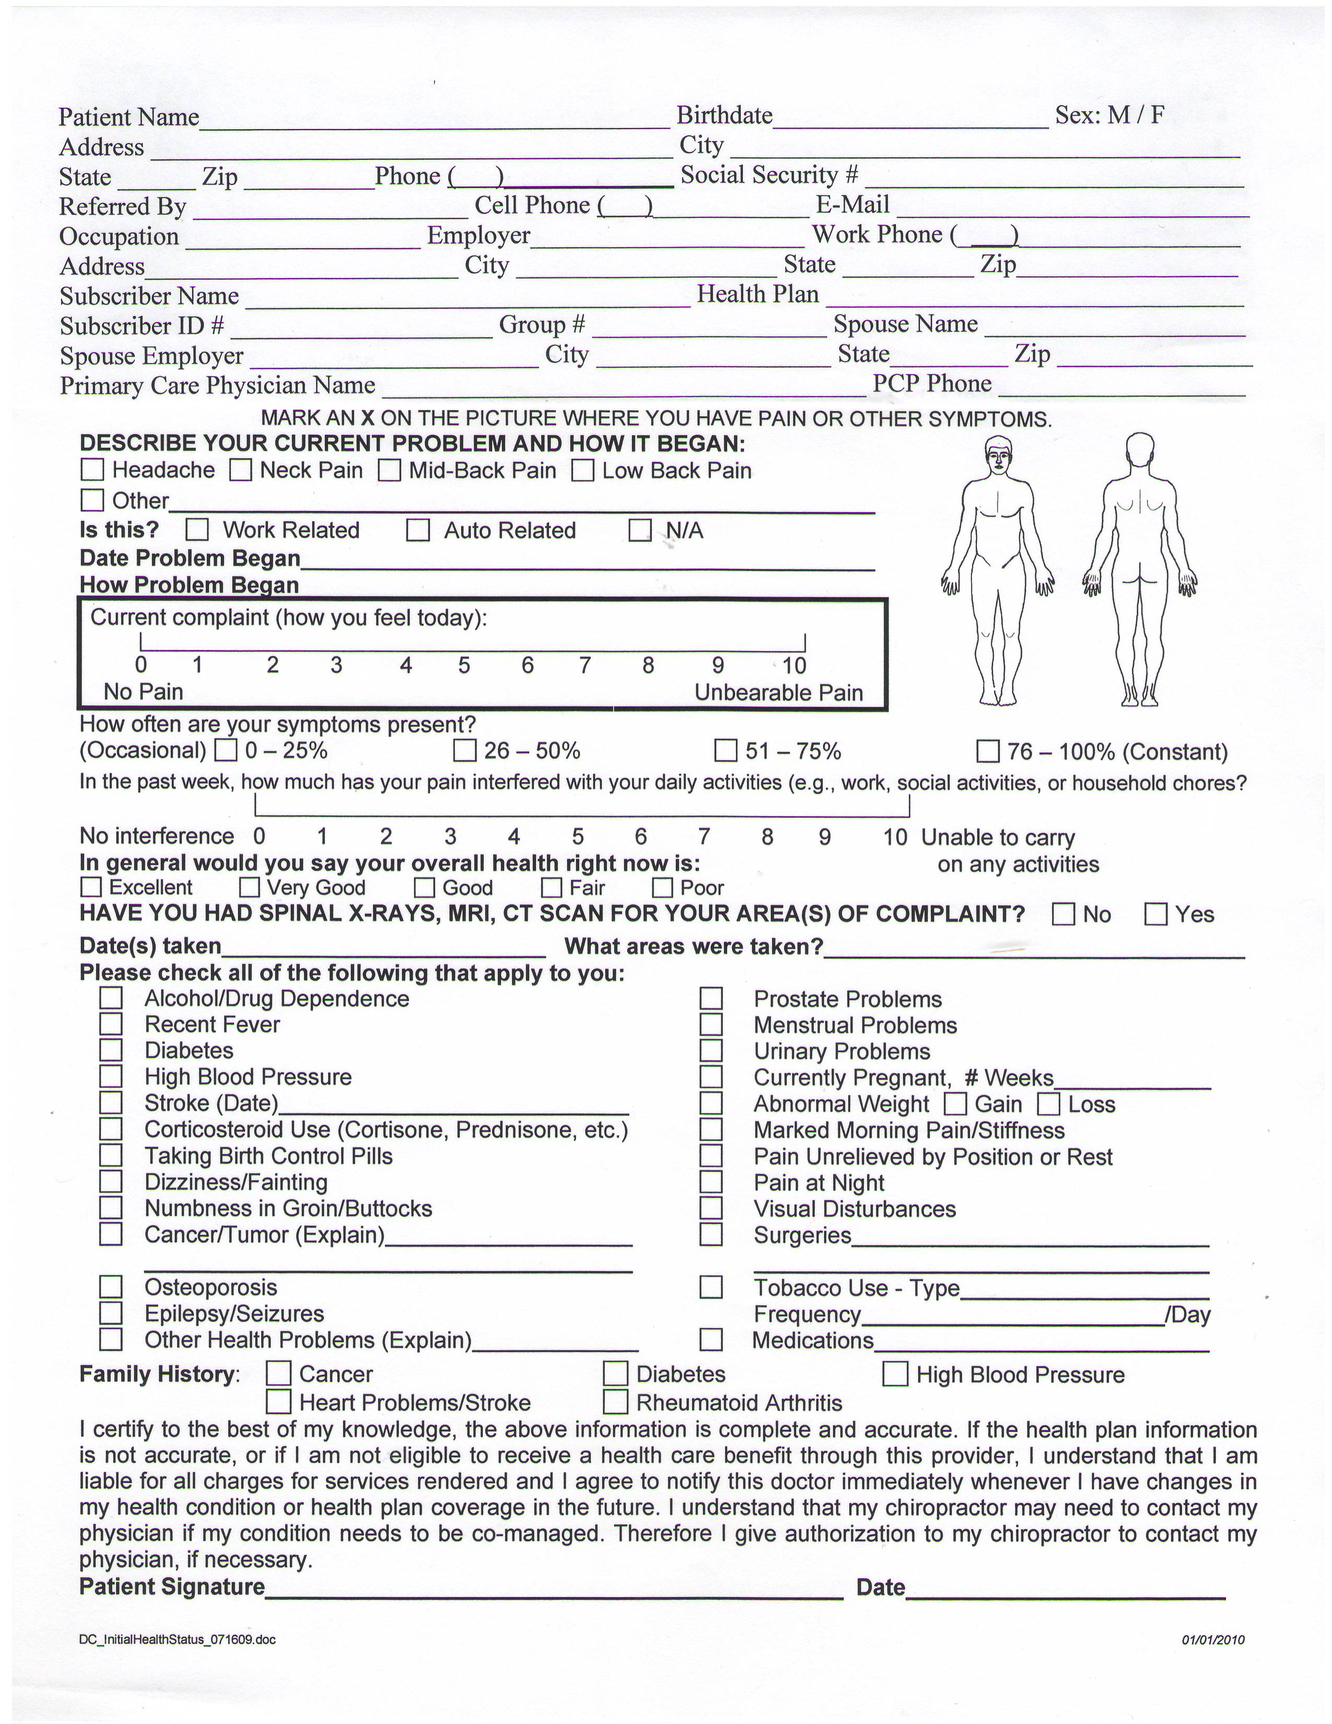

SIMON CHIROPRACTIC, INC.

OPEN-DOOR ENVIRONMENT

IT IS THE DESIRE OF THIS OFFICE TO PROVIDE CHIROPRACTIC CARE IN AN "OPEN-DOOR ADJUSTING ENVIRONMENT. AN OPEN-DOOR APPROACH INVOLVES THE DOCTOR MOVING FROM PATIENT CARE AREA TO PATIENT CARE AREA AND LEAVING THE DOORS BETWEEN PATIENT CARE AREAS OPEN. AS A RESULT PATIENTS ARE OCCASIONALLY WITHIN SIGHT OF ONE ANOTHER AND SOME ONGOING ROUTINE DETAILS OF CARE ARE DISCUSSED WITHIN EARSHOT OF OTHER PATIENTS AND STAFF. THIS ENVIRONMENT IS USED FOR ONGOING CARE AND IS NOT THE ENVIRONMENT USED FOR TAKING PATIENT HISTORIES, PERFORMING EXAMINATIONS OR PRESENTING REPORTS OF FINDINGS. THESE PROCEDURES ARE COMPLETED IN A PRIVATE, CONFIDENTIAL SETTING.

WE ARE REQUESTING THIS AUTHORIZATION OF YOU DUE TO VARIOUS INTERPRETATIONS UNDER FEDERAL LAW WITH RESPECT TO WHAT IS KNOWN AS AN "INCIDENTAL DISCLOSURES" OF HEALTH INFORMATION. IT IS OUR VIEW THAT THE KINDS OF MATTERS RELATED IN AN "OPEN DOOR" ENVIRONMENT ARE INCIDENTAL MATTERS, IN THE EVENT YOU OR SOMEONE ELSE WOULD NOT AGREE WITH US WE ARE PROVIDING THIS DISCLOSURE AND REQUESTING YOUR AUTHORIZATION.

THE USE OF THIS FORMAT IS INTENDED TO MAKE YOUR EXPERIENCE WITH OUR OFFICE MORE EFFICIENT AND PRODUCTIVE AS WELL AS TO ENHANCE YOUR ACCESS TO QUALITY HEALTH CARE. IF YOU CHOOSE NOT TO BE ADJUSTED IN AN OPEN-DOOR ADJUSTING ENVIRONMENT OTHER ARRANGEMENTS WILL BE MADE FOR YOU. YOUR DECISION WILL HAVE NO ADVERSE EFFECT ON YOUR CARE OR ON YOUR RELATIONSHIP WITH OUR STAFF.

YOUR SIGNATURE INDICATES YOUR AUTHORIZATION OF THIS ACTIVITY.

___________________________ _____________________________ ____________
NAME (PRINTED) SIGNATURE DATE

THIS AUTHORIZATION MAY BE REVOKED BY YOU AT ANY TIME. REVOCATION MAY BE ACCOMPLISHED BY ADVISING US IN WRITING OF YOUR DESIRE TO WITHDRAW YOUR AUTHORIZATION.

TERMS OF ACCEPTANCE
_____________________________________________________________________________

When a patient seeks chiropractic health care and we accept a patient for such care, it is essential for both to be working towards the same objective.

Chiropractic has only one goal. It is important that each patient understand both the objective and the method that will be used to attain it. This will prevent any confusion or disappointment.

Adjustment: An adjustment is the specific application of forces to facilitate the body's correction of vertebral subluxation. Our chiropractic method of correction is by specific adjustments of the spine.

Health: A state of optimal physical, mental, and social well being, not merely the absence of infirmity.

Vertebral Subluxation: A misalignment of one or more of the 24 vertebra in the spinal column which causes alteration of nerve function and interference to the transmission of mental impulses resulting in a lessening of the body's innate ability to express its maximum health potential.

We do not offer to diagnose or treat any disease or condition other than vertebral subluxation. However, if during the course of a chiropractic spinal examination, we encounter non-chiropractic or unusual findings, we will advise you. If you desire advice, diagnosis or treatment for those findings, we will recommend that you seek the services of a health care provider that specializes in that area.

Regardless of what the disease is called, we do not offer to treat it. Nor do we offer advice regarding treatment prescribed by others. OUR ONLY PRACTICE OBJECTIVE is to eliminate a major interference to the expression of the body's innate wisdom. Our only method is specific adjusting to correct vertebral subluxations.

I,___________________________have read and fully understand the above statements.
(print name)
All questions regarding the doctor's objectives pertaining to my care in this office have been answered to my complete satisfaction.

I therefore accept chiropractic care on this basis.

_____________________________________ ___________________
(signature) (date)

Notice of Privacy Practices

All information that is obtained from you by this office is protected and kept confidential. Every reasonable measure to prevent unauthorized disclosure of your protected health information is practiced.

Uses and Disclosures

- Your protected health information is accessed and used for healthcare related purposes only.
- Your protected health information is never sold, rented, transferred, exchanged, and/or used for non-healthcare related purposes including marketing activities without your written authorization.
- Your protected health information is disclosed to third-party entities without your written authorization for the purpose of treatment, to obtain payment for treatment, and for healthcare operations.

Certain Circumstances

Your protected health information can be disclosed without your written authorization in certain limited circumstances.
- Medical emergencies
- In situations required by law
- Individuals involved in your care
- When requested by public health agency
- When requested by a law enforcement agency

For any purpose other than treatment, obtaining payment, healthcare operations, or certain circumstances, we will ask for your written authorization before using or disclosing your protected health information. If you choose to sign an authorization to disclose protected health information, you can revoke that authorization in writing at any time.

Patient Rights

- You have the right to request in writing to inspect and/or receive a copy of your health information. A fee may apply.
- You have the right to request an alternate means or location to receive communications regarding your health information. Conditions apply.
- You have the right to request in writing to amend, correct, or delete any recorded health information within our possession. Conditions apply.
- You have the right to request in writing an accounting of certain disclosures of your health information that were made by this office. Conditions Apply.

Changes To This Notice: We reserve the right to change privacy practices and the conditions of this notice at any time and without prior notice. In the event of changes, an update notice will be posted and a copy will be sent to you.

Patient’s Signature:___________________________________

